# **ASSIGNMENT 1**

**Question 1: Produce a line plot showing multiple lines with proper labels and legend. Describe what conclusions you can draw from this plot.**

**Solution:**

**Line Graph:**

**Description:**

The line graph visualizes the fluctuation of different entities in a data set with respect to time.

**Reason of selection:**

The reason of selecting a line graph is that it track changes with the course of time and easily handle the large bulk of data. The user can easily visualize its organization profits and expenses and can manage them overtime.

**Code:**

**#imporitng libraries**

import pandas as pd

import matplotlib.pyplot as plt  
**#reading data from file**

file = pd.read_excel("F:\\stock ex.xlsx")

**#checking all the columns of the data**

file.columns

**#sperating the exel data and saving it inside variables**

total_com = file['Total No. of Listed Companies']

total_com

total_cap = file['Total Listed Capital - Rs']

total_cap

total_mar = file['Total Market Capitalisation - Rs']

total_mar

**#now let's plot the graph**

plt.figure(figsize= (12,3))

plt.plot(file.loc[:,"Years"],total_mar, color="blue", label="total market capitalization")

plt.plot(file.loc[:,"Years"],total_cap,color = "red" , label="total listed capitals")

plt.plot(file.loc[:,"Years"],total_com,color="green", label="total companies")

plt.grid(linewidth=1)

plt.legend()

plt.xlabel("Years")

plt.ylabel("Analysis")

plt.title("Stock Managment")

**Output:**

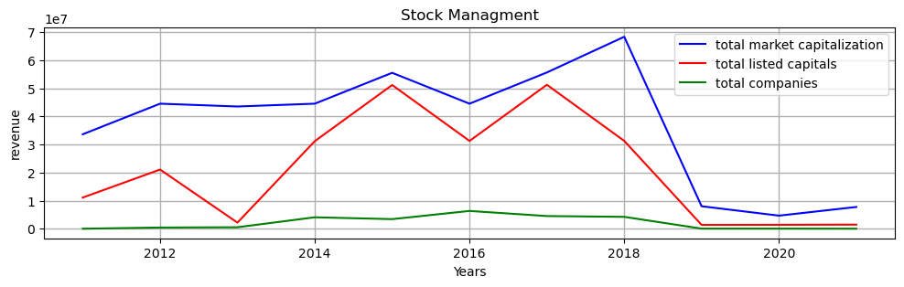

**Link:** <https://dps.psx.com.pk/>

**Conclusion:**

When a user takes a good look in to the graph he can clearly analyze the fluctuation in the stock market of Pakistan over the years of time. The green line of this graph analyzes different companies investing on stock exchange thus an increase in the capitalization of the market shown using a blue line thus increasing assets lead to increase number of capitals thus increases the market worth and profit which can clearly be analyzed by using the red line.

**Question 2: Produce graphs using two other visualisation methods. Explain why you picked this type of graph and describe what conclusions you can draw.**

**Solution:**

**Part A:**

**Bar plot:**

**Description:**

A bar plot shows the relationship between the distinct values in the categorized data in different entities. There are two types of bar plot one is knows as grouped bar graph and the other is known as stacked bar graph. In grouped bar graph we can clearly visualize the data in the form of grouped boxes but in stacked bar graph we can visualize the boxes paced upside down to one another.

**Reason of selection:**

The reason I selected this graph is because we can visualize multiple data sets which can be easily understandable and we can categories our data in a very simpler way then of other graphs.

**Code:**

**#importing all libraries**

import pandas as pd

import matplotlib.pyplot as plt

**#reading data from an exel sheet**

file = pd.read_csv("C:\\Users\\HANZALLAH\\OneDrive\\Desktop\\Q2.csv")

**#rearranging data and ploting a graph**

file.pivot(index='state',columns='cause of death',values='deaths').plot(kind='bar',stacked =True,figsize = (15,8),width = 0.7)

**#labelling and giving title to the graph**

plt.xlabel('Us states')

plt.ylabel('Recorded deaths')

plt.title('Deaths recorded jan 2020')

**Output:**

**Grouped bar graph:**

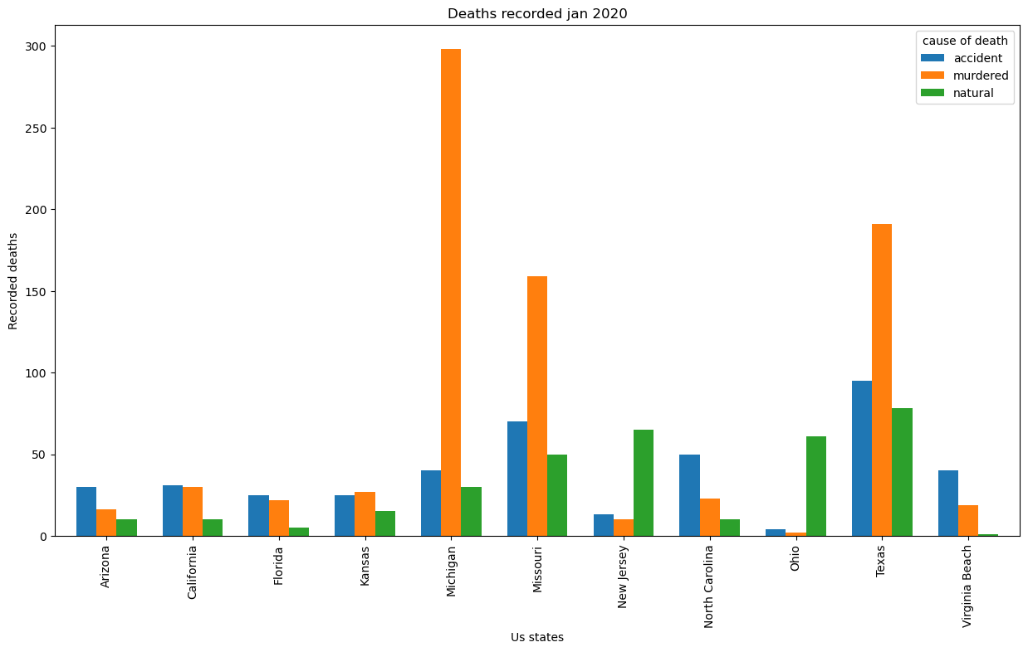

**Stacked Bar Graph:**

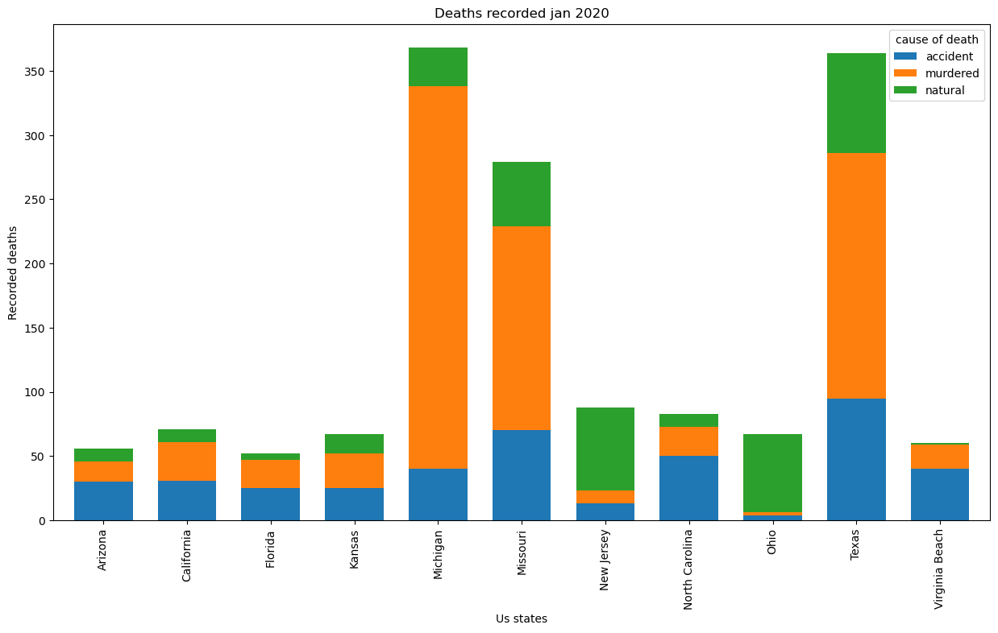

**link:** https://data.fivethirtyeight.com/

**Conclusion:**

When a user takes an analysis of this graph the user can easily understand the number of deaths in different cities of the US and the causes of their deaths. The x-axis of this graph visualizes the name of the cities and in y-axis e can visualize no of deaths caused on those cities.

**Part B:**

**Pie Chart:**

**Description:**

A pie chart is the circular statistical plot that can display series of one data. The area of the chart displays the percentage of the given data. The area of slices of the pie represents the percentage of the parts of data.

**Reason of selection:**

The reason of using the pie charts is that it helps us to understand the whole relation in an organization like it gives the visualization of all the members in an organization and tells the percentage of the users present in organization.

**Code:**

**#importing all libraries**

import pandas as pd

import matplotlib.pyplot as plt

**#reading data from an exel sheet**

file = pd.read_csv("C:\\Users\\HANZALLAH\\OneDrive\\Desktop\\MOD-Organogram of Staff Roles & Salaries-Royal Air Force Museum.csv")

file.head(2)

**#creating a new file to saperate the job title column and to count all categories**

new_file = file['Generic Job Title'].value_counts().rename_axis('job titles').reset_index(name='counts')

**#to print all the data**

print(new_file)

**#get total of count values**

total_count = new_file.counts.sum()

total_count

**#to add value with the percentage**

def your_autopct_format(prct_value):

print(prct_value)

return '{:.4f}%\n{:.0f}'.format(prct_value, total_count*prct_value/100)

**#setting our label and values**

job_titles = new_file['job titles']

job_titles

counts = new_file['counts']

counts

y_explode = [0,0.1,0,0,0]

**#creating our pie chart**

fig = plt.figure()

ax = fig.add_axes([0,0,1,1])

ax.axis('equal')

ax.pie(counts,labels=job_titles,autopct=your_autopct_format,explode=y_explode)

plt.title('total members of royal airforce meseum')

plt.legend(loc='center left',prop={'size': 5})

**Output:**

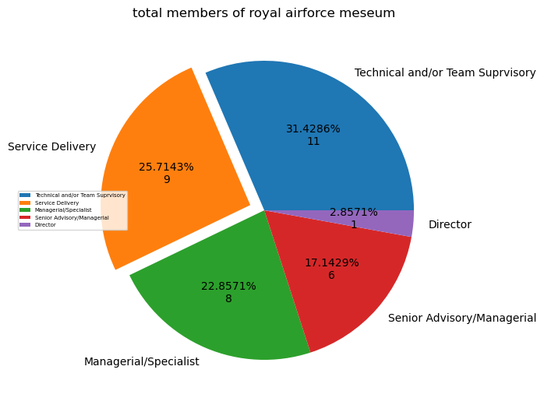

**link:** https://www.data.gov.uk/dataset/2560e1b6-5b56-4119-babd-9a5c5cd07aff/mod-organogram-of-staff-roles-salaries-royal-air-force-museum

**Conclusion:**

When a user takes an analysis of this graph the user can easily differentiate between different departments in an organization and can easily tell the percentage of employees in each of the department just by looking in to the graph. The user can easily tell the no of employees available in these departments and can easily calculate the whole of organization members.